FrAME ToolBox Import

Manual How to import the MDG FRAME Toolbox

Benjamin Witsch, Alexander Frötscher

Mai 2020

# Introduction

## Task

FRAME NEXT will extend the approach of the existing and extended set of “FRAME tools” with strategic ( and business oriented architectural views, called “Business FRAME” (see diagram above). These views will explain, and give guidance on, how policy and strategic ideas/concepts as well as business rules and processes can be transferred to, and implemented by, the deployment of real ITS and C-ITS services.

## Motivation

1. ITS location Models are used in the encapsulation, if necessary.

# EA Manual Import FRAME TOOL BOX

## Open a EA project file

Link: <https://files.austriatech.at/#my-libs/lib/5ffeff21-ba3f-48cd-9424-2f1ab336774e/06_EA%20Development/FRAME%20Toolbox>

## Download the Toolbox from Filerepository

…or generate a new.

## Import MDG File

Go to Spezialize / PublishTech / Import MDG Technology

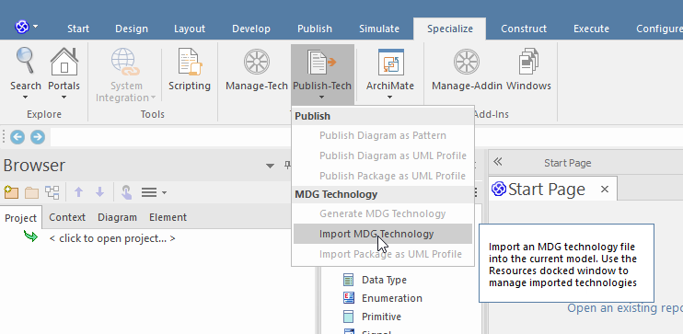

## Import MDG File

Select within the filename the FRAME_MTS file from the downloaded Toolbox:

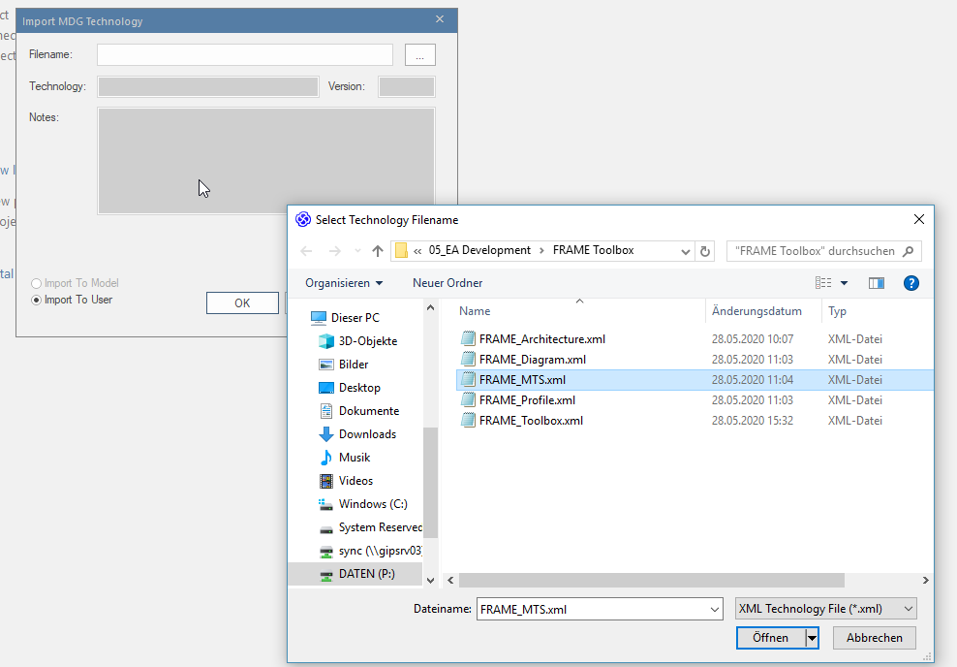

And Press OK.

# EA Manual Use FRAME TOOL BOX

## Add a FRAME Diagram to load the Toolbox

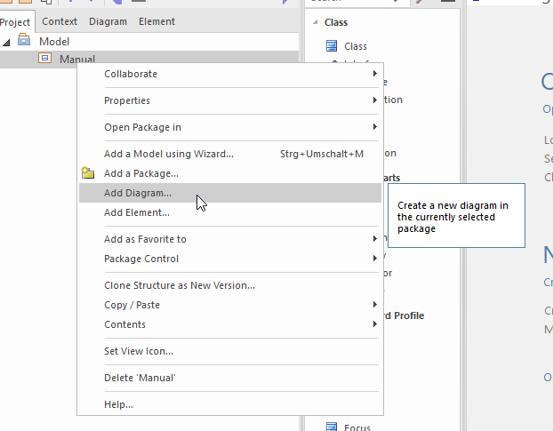

Select FRAME_Diagram as type:

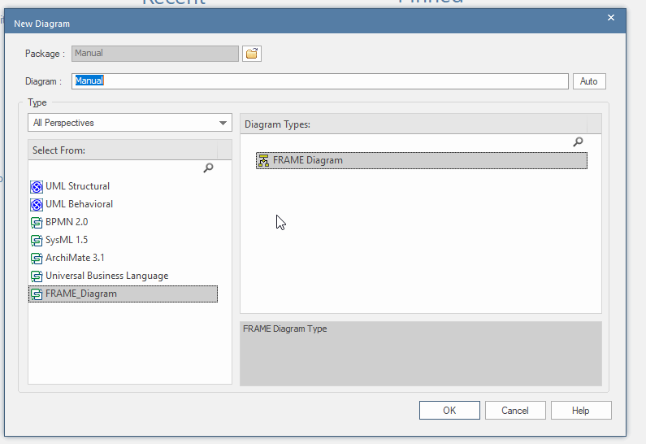

## Select FRAME Toolbox

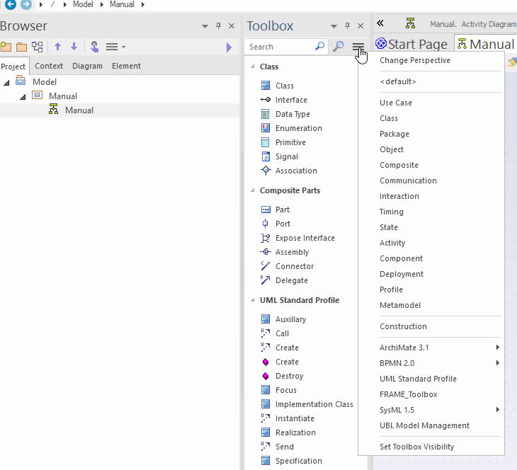

Now The Toolbox can be used.